**Overall Score**



**Blog**

* **Question 1**
* I am blogging this question because it made me think a little bit. This segment would still set z as the max value, because it iterates through the second if loop and the conditions of the if loop to set y as the max aren’t met, and so z would be set as max in the end due to the else statement.

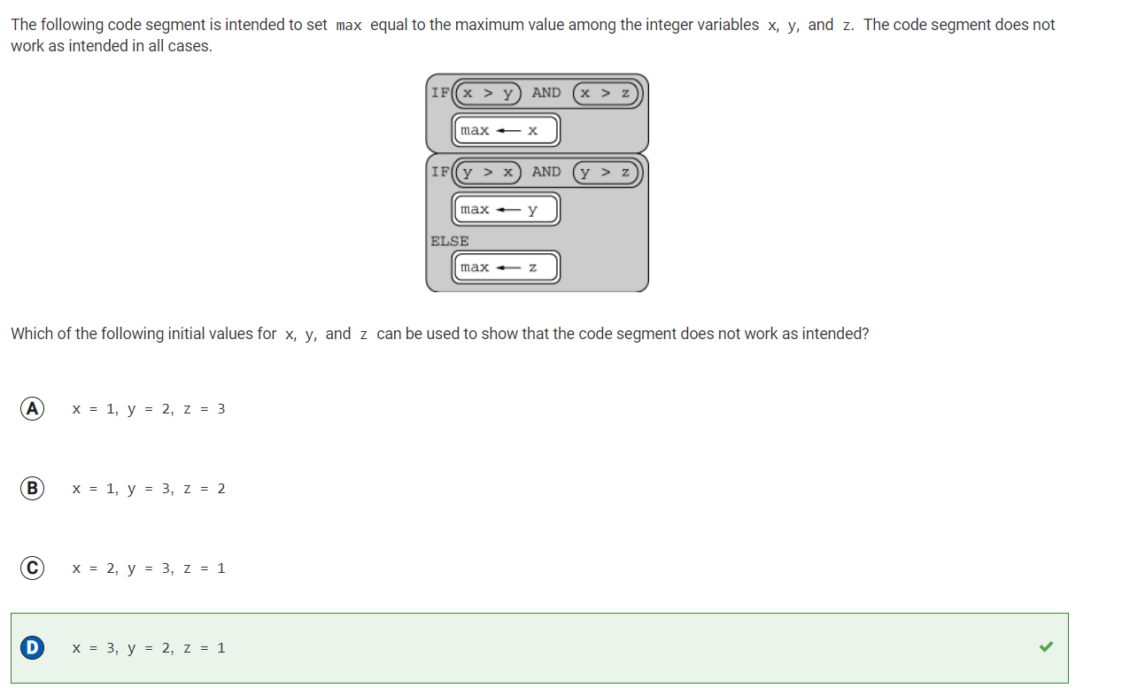

* **Question 13**
* I got this question wrong because I selected the Boolean which used an and expression instead of an or expression. The and expression can only be true if both conditions are met simultaneously. However, no number can be BOTH equal to 15 and also greater than 15 at the same time. Therefore, we must use the OR operation.

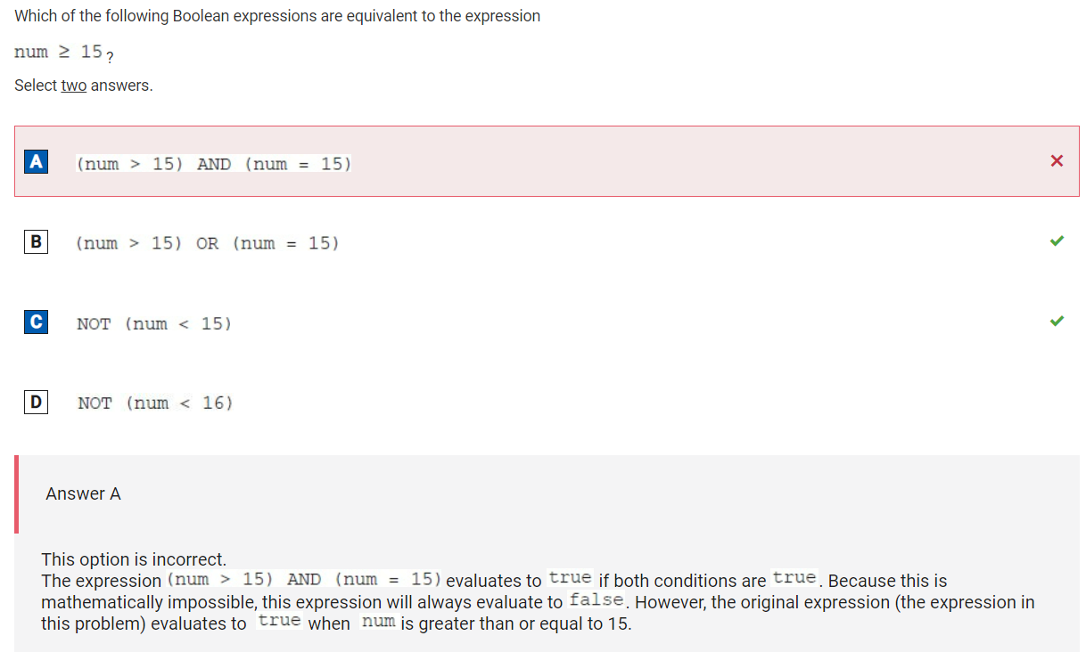

* **Question 15**
* I chose to blog this question because it took me a really long time to answer. I had to run through the code segment in my head and visualize it. However, eventually I chose this as the answer because at the end, it would choose to turn right first instead of left as indicated by the order of statements in the if loop, thus landing it on the right side of the maze as an endpoint rather than on the left as desired.

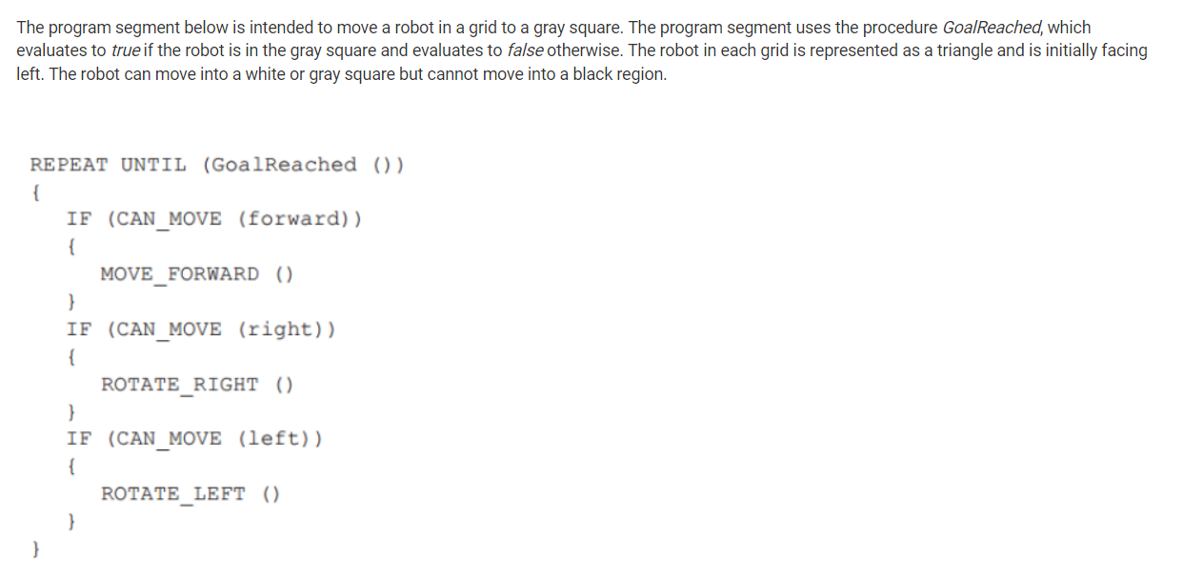

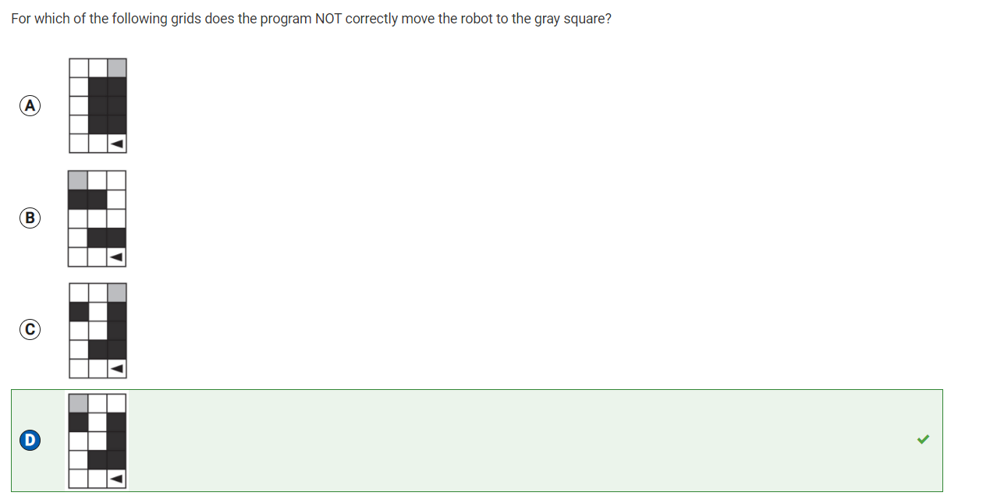

* **Question 22**
* I misread this question. I thought that algorithm A was sampling with replacement, which meant that heights could be repeated. However, in algorithm A, each student was chosen from a standing group of students, who would sit down once their turn was over. So, this method would also work. I thought they were just randomly selecting from the same pool of people, which could allow for repeat heights and an incorrect calculation of the average.

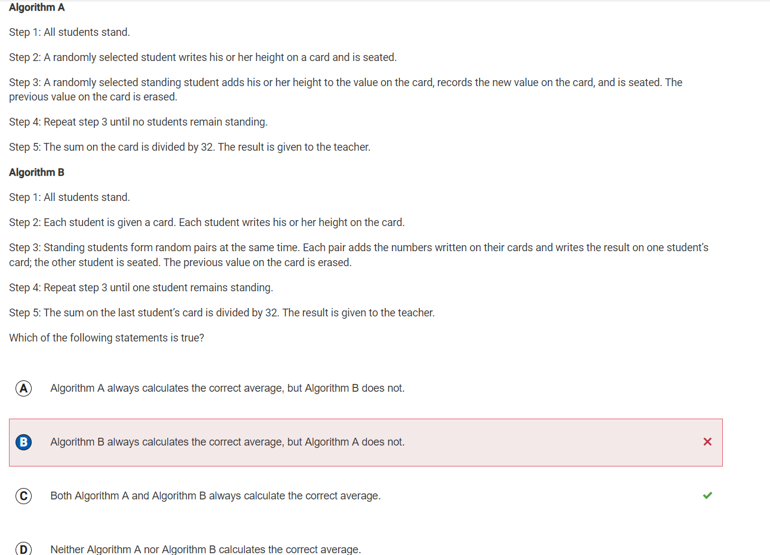

* **Question 16**
* I chose to blog this question because I didn’t know what “selection” meant. I now know that selection allows you to “select” the items in a list that meet a particular criteria.

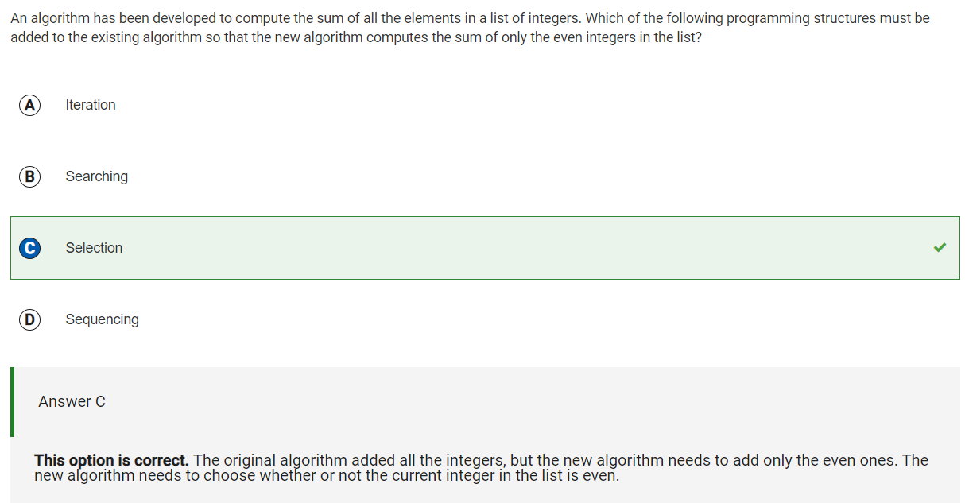

* **Question 30**
* Going to be completely honest here, I didn’t understand this question. I would appreciate an explanation, but collegeboard did not supply us with one.

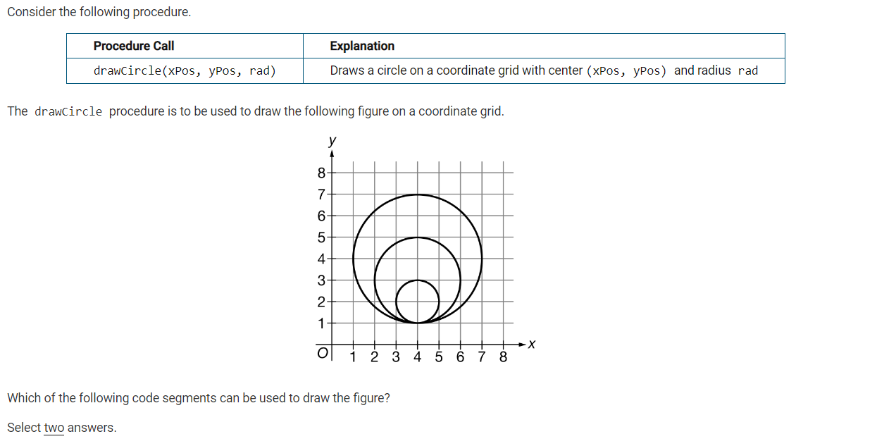

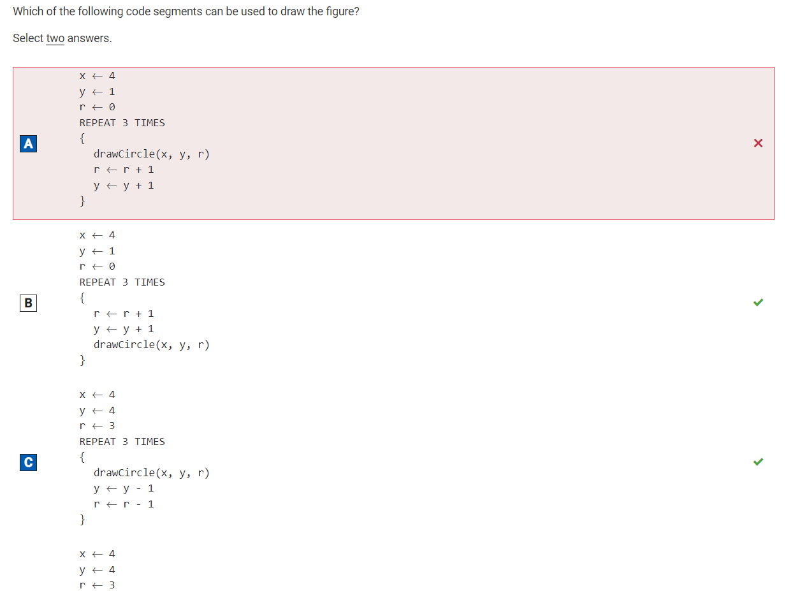

* **Question 45**
* Before this question, I did not know what a heuristic solution was. I learned that a heuristic solution is one that can be solved in a shorter period of time and comes up with an approximate solution.

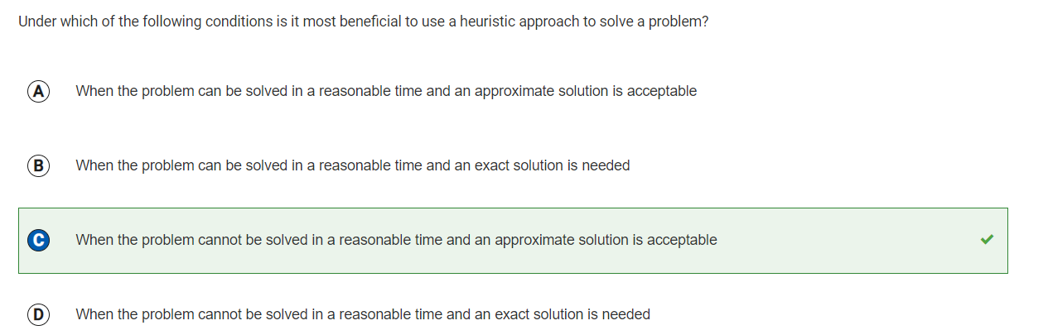

* **Question 50**
* Never heard of this or learned about it. Needs some review.

